DOM Manipulation

Main things that is discussed

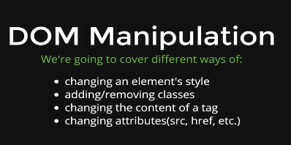

Manipulation – 1

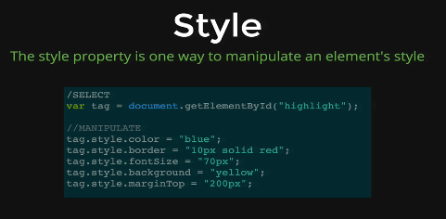

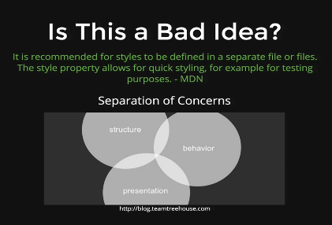

Separation of concerns is when we should not cross over HTML, CSS, and JavaScript while it would cause many interference

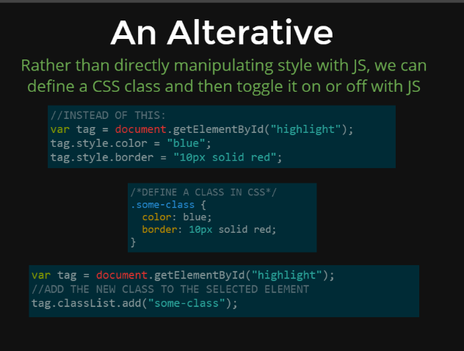

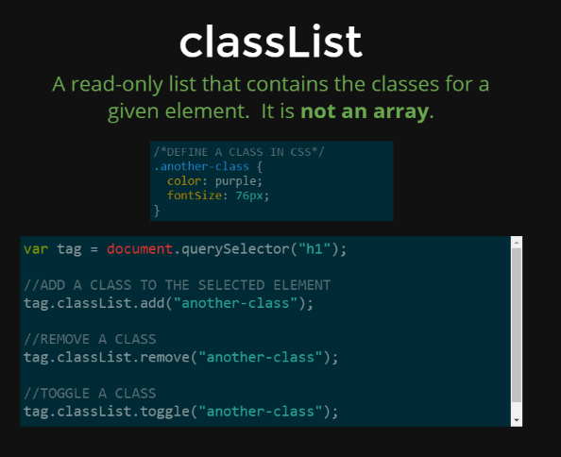

We have discussed 2 different ways to manipulate styles through our JavaScript

**Style** – Manually and doing things one thing at a time.

**Using Class (An Alternative)** – When we would use a class